**PetCare+ –>Specialized Veterinary Treatment Slot Booking System**

**PHASE 9**

**1. Reports (Tabular, Summary, Matrix)**

* **Why:** Needed to show slot bookings, appointments per doctor, and monthly appointment trends.
* **Use:** You’ll create **Summary Reports** like *Slots by Doctor – Monthly* and *Monthly Appointment Volume*.

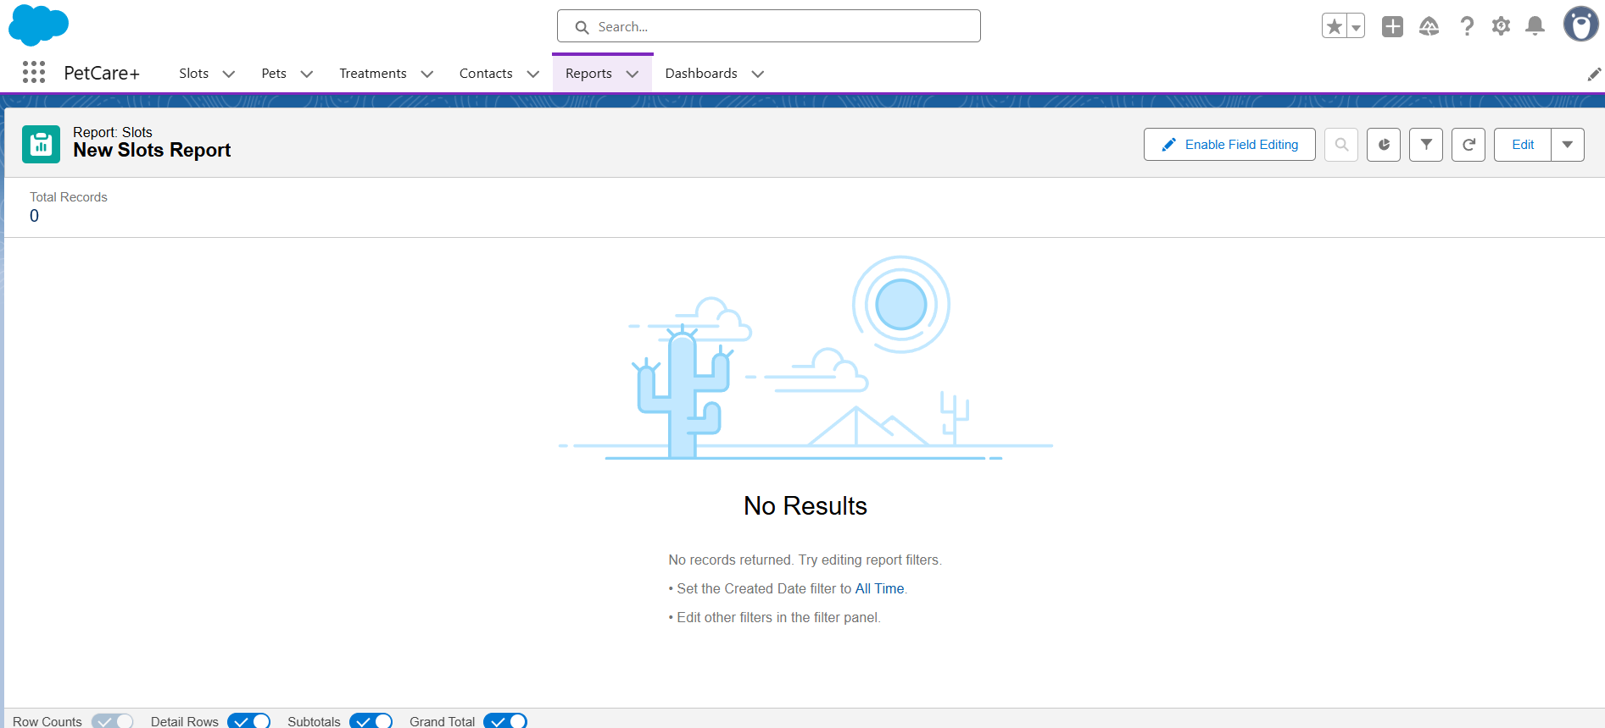

**2. Report Types**

* **Why:** Allows custom reporting on your objects if standard report types don’t exist.
* **Use:** Create a custom report type for **Slot__c** to feed your dashboards.

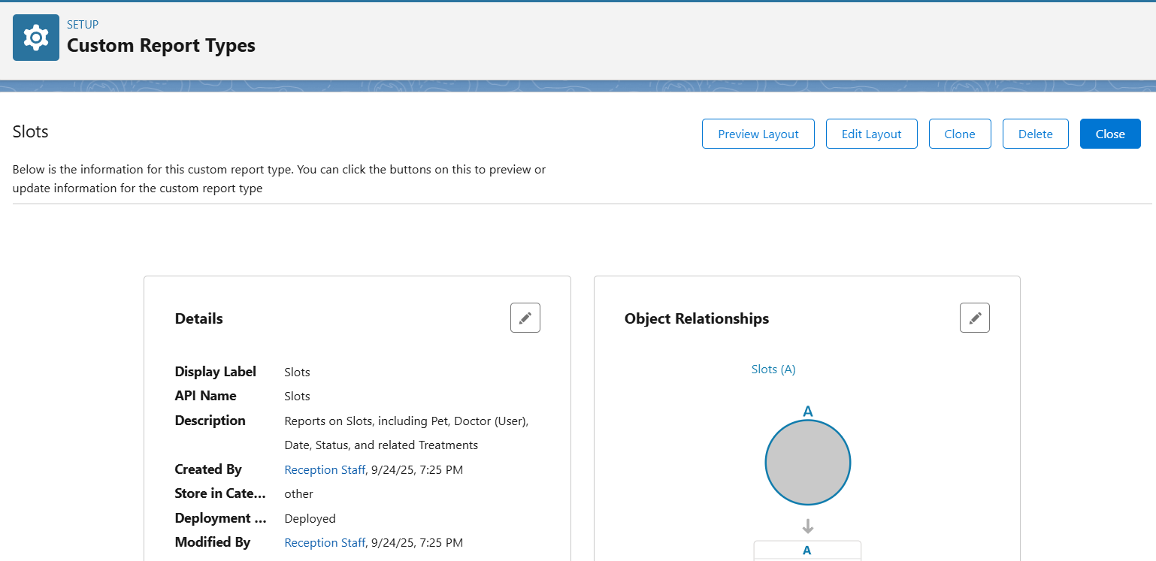

**3. Dashboards**

* **Why:** To visualize reports for clinic admin or receptionist in one place.
* **Use:** Add charts from your reports like *Slots by Doctor* and *Monthly Appointment Volume* to a **PetCare+ Dashboard**.

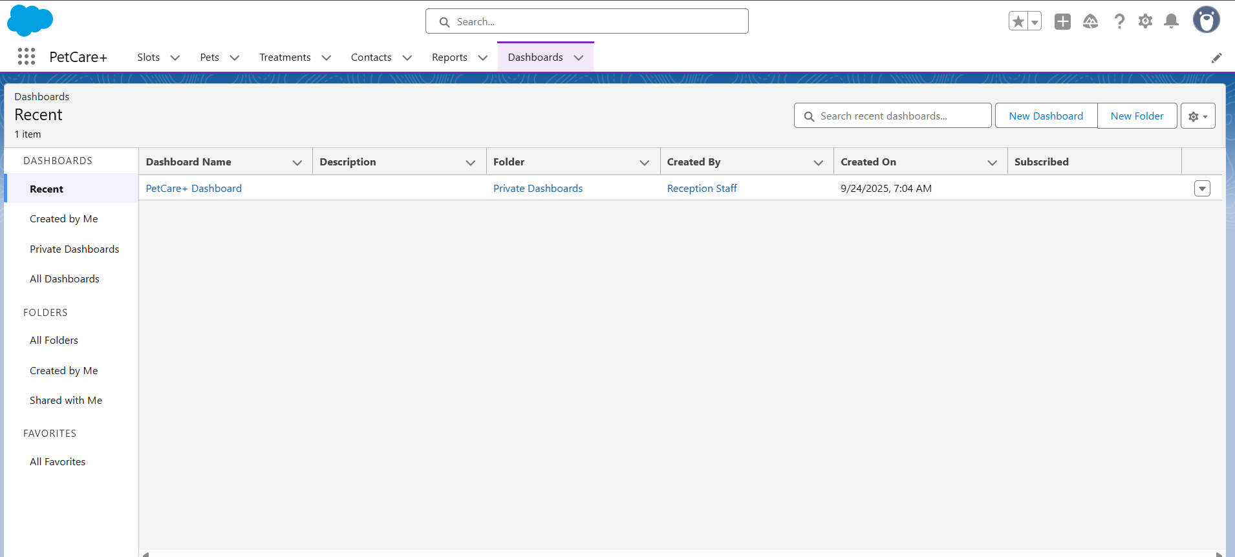

**4. Sharing Settings**

* **Why:** To control who can view or edit records in your org.
* **Use:** Ensure **Doctors** can only see their slots/treatments, **Receptionists** can create/edit slots, and **Admins** have full access.
* 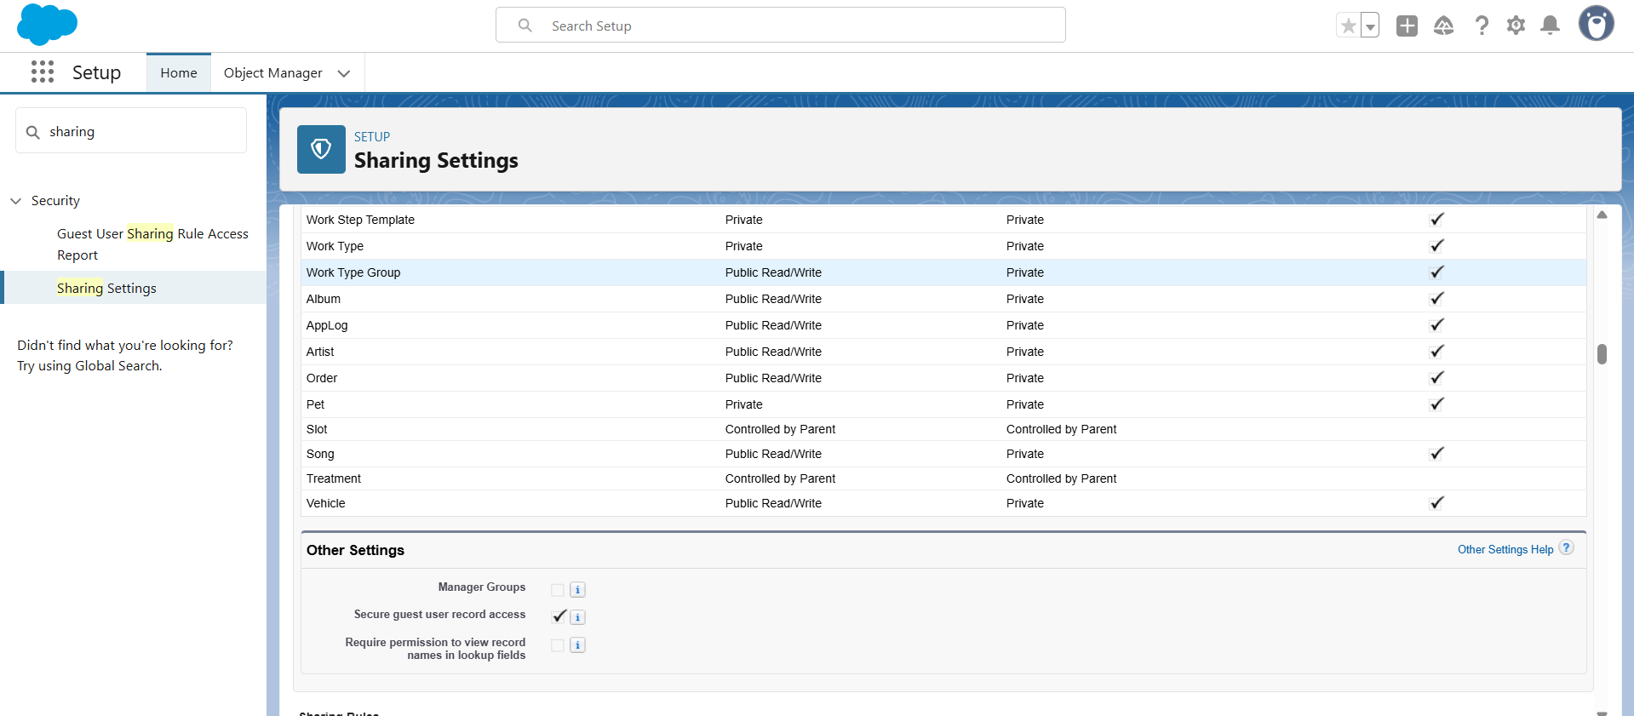

**5. Field Level Security**

* **Why:** To protect sensitive data like pet owner contact info or fees.
* **Use:** Set read/write permissions per profile for fields on Pet__c, Slot__c, and Treatment__c.

